Use-Case Realization Report
Take Exam

Issue 1.0
Revision History
Date | Issue | Description | Author
<dd/mmm/yy> | <x.x> | <details> | <name>

Table of Contents
1. Brief Description 4
2. Flow of Events 4
2.1 Standard Flow 4
2.2 Exceptions 4
3. Interaction Diagrams 5
3.1 Collaboration Diagram for Take Exam 5
4. Participating Objects 5
5. Class Diagrams 6
5.1 Class Diagram for Take Exam 6
6. Derived Requirements 6

Use-Case Realization Report
Take Exam

Brief Description

Flow of Events

Standard Flow
1. User clicks the “Exam name” link, exam starts.
2. According to the exam settings, system will randomly pick up questions and form up the exam.
3. System will record the lapsed time, compare with the duration setup of the exam, and will terminate the exam is time is up.
4. During exam, user can click the button to view the next question and the previous questions.
5. After finishing all the questions, user clicks the button to submit the paper.
6. The result will be saved for reference.

Exceptions
1. System will record the lapsed time, and compare with the duration setup of the exam, and will terminate
2. If the user takes the same exam before, the system will check whether the exam allows re-take, and if not, the user will not be able to take this exam again.

Interaction Diagrams

Collaboration Diagram for Take Exam
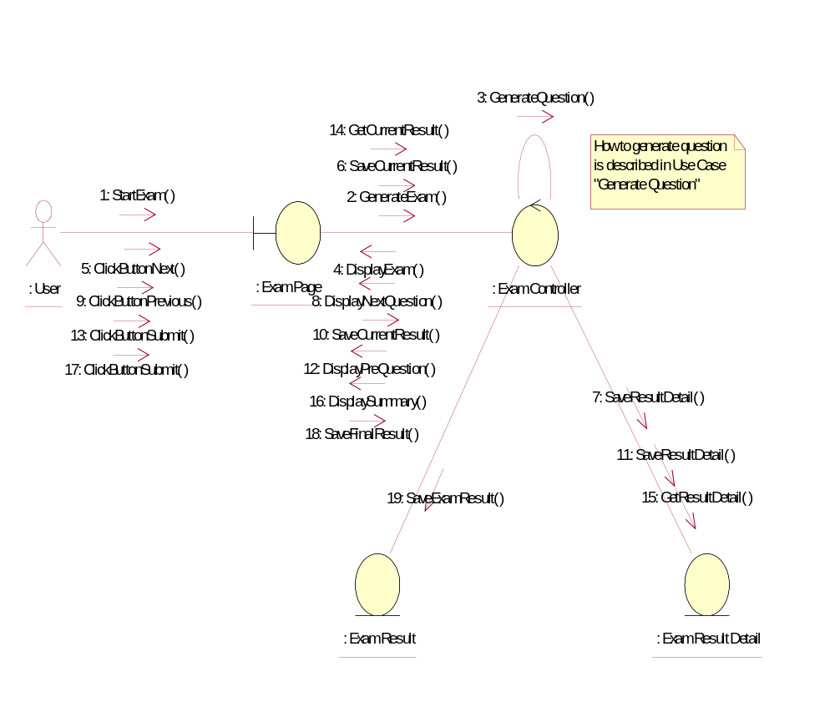

Participating Objects
: Exam Controller
This cotroller will in charge of creating exam questions, monitoring exam progress, like the user answers, and the time spent, navigating questions etc. It will also save the result into Exam Result table and Exam Result Detail table.
: Exam Page
This page displays the questions and the navigation buttons.
: Exam Result
This entity saves the exam summary, containing userID, examID and the marks.
: Exam Result Detail
This entity contains the details of the exam, like each answer for each questions etc.
: User
This is the end-user of the system

Class Diagrams

Class Diagram for Take Exam
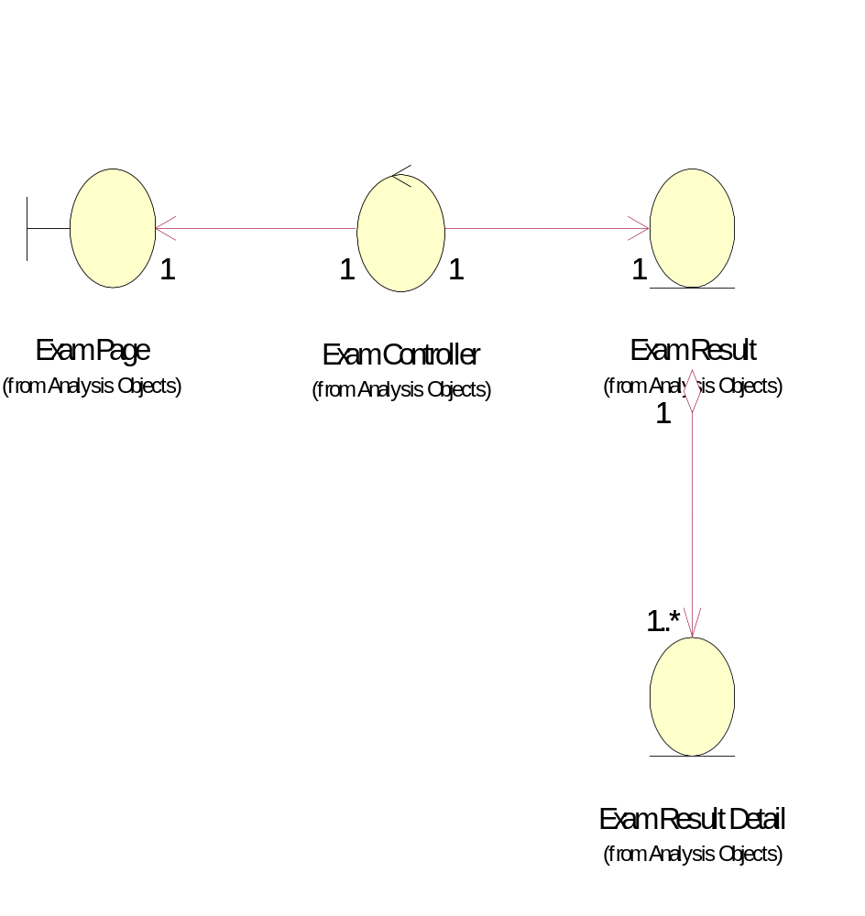

Derived Requirements
User must have the DAP rights on the exam to be taken.

